**Project Report**

**Topic: - Design and Development of a Music Streaming Application Database Spotify**

**Project Overview:** We are implementing a database system for a Spotify like music streaming application. The database will have a central role to improve the user experience by recommending playlists and songs based on the songs playback history and their favorite songs which improves the quality of recommendation since each user will have unique liked list based on their music taste.

**Problem statement: -**The music streaming industry is highly competitive, with numerous platforms vying for user engagement. The problem we are facing is to keep the user pact, recommendation system needs to be improved and for that the user personalized playlist based on their prior engagement with the music there, liking towards the music genre needs to be considered for that How we collect the database and utilizes it matters and our project aims for that.

**Objective:-  
Personalization and User Engagement***:* In today’s digital era one size fit all will not workout.so, user recommendation needs to be tailored to individual tastes and preferences.

**User Retention***:* User who discover new music and likes it are more likely to be engaged with the music. So, we aim to find a way to keep the user back by offering the relevant content.

**Data Tracking and Analysis**: analyzing the user behavior is one of the key points to improve the application. We must be able to track user interactions, such as song plays, likes, and playlist creations, to gain insights into user preferences and habits.

**User Satisfaction:** Ultimately, user satisfaction is the foundation of a successful music streaming platform. Users should find the application easy to use, enjoyable, and responsive to their music preferences.

**Business Problem –**

The music streaming sector encounters various challenges, such as the demand for tailored user experiences, maintaining user loyalty, precise data monitoring and competitive pressures. Our project seeks to tackle these issues by constructing a database system that offers:

**Solution Strategy –**

• **Personalized song recommendations: -** By analyzing a user's listening history, likes, dislikes, and other interactions, the platform can create custom playlists and recommend new tracks that cater to their unique tastes.

• **Efficient tracking of song play history: -** This data can be used to refine recommendation algorithms, understand user behavior, and make informed decisions about content curation.

• **Competitive Edge through Unique Features and Recommendations: -** In a crowded market, offering unique features and recommendations can set a music streaming platform apart from competitors. By providing features that users can't find elsewhere, such as exclusive content or innovative playlist options, the platform can attract and retain a loyal user base.

**For the solution we have designed a ER Diagram of the Database. It is shown below:**

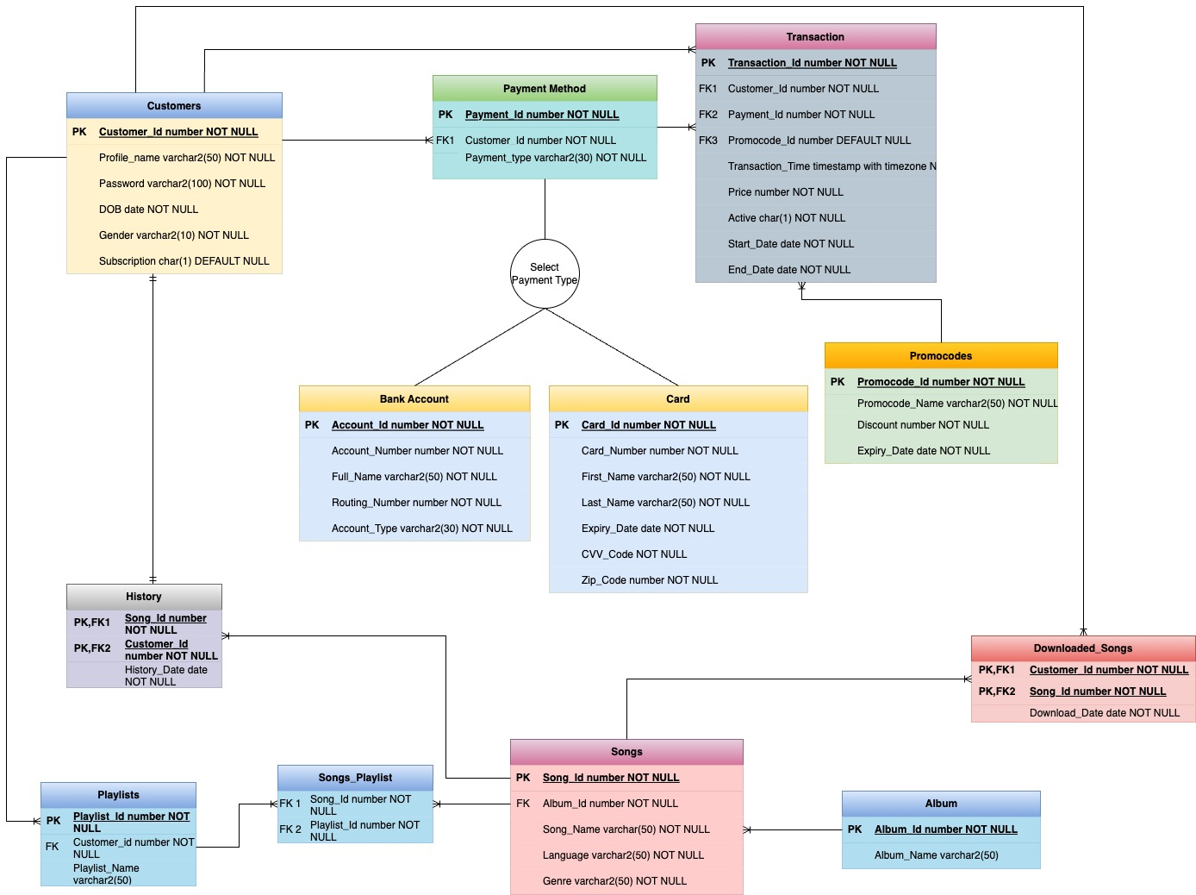

**Data flow is as below: -**

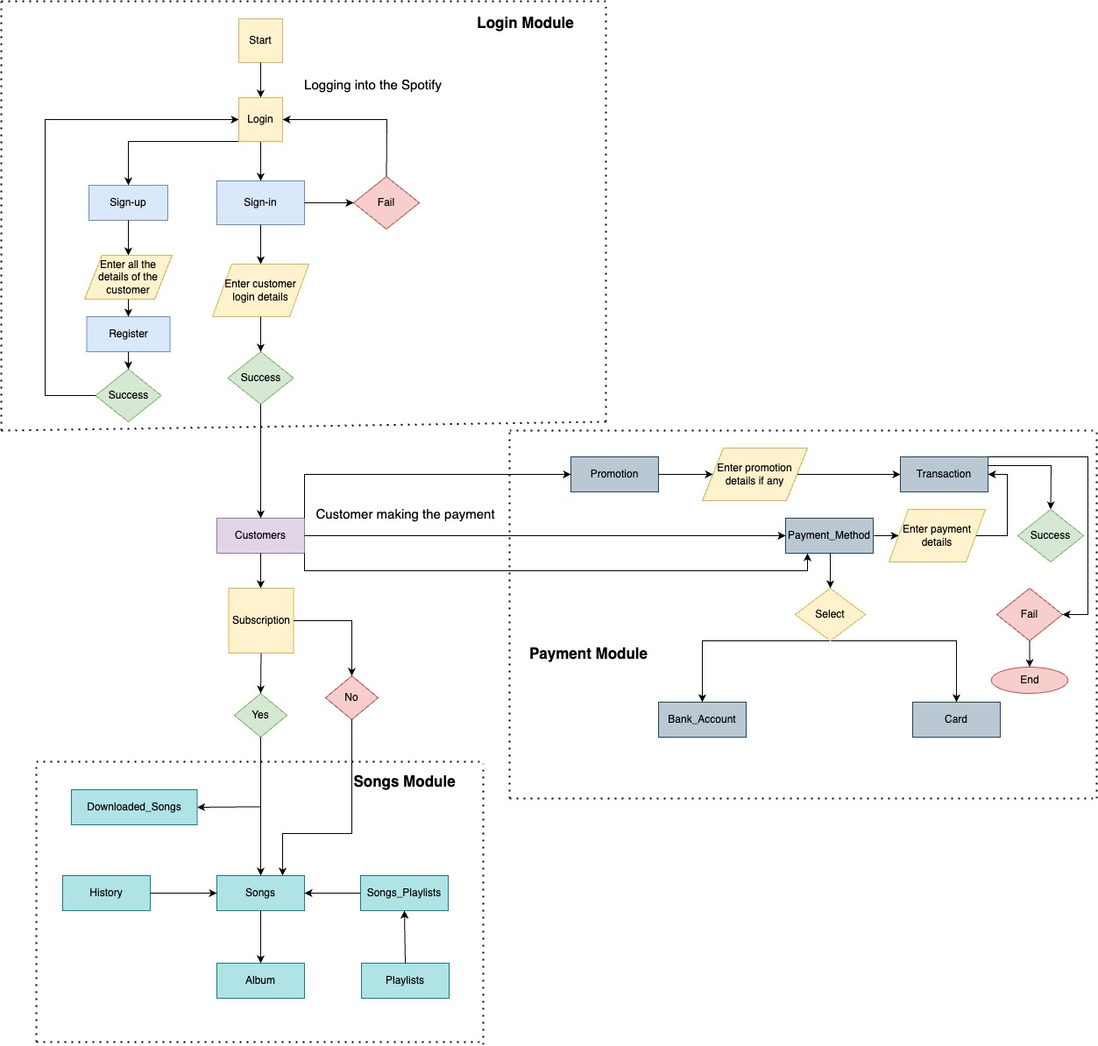

**Tables: -**

**Attributes and entity**

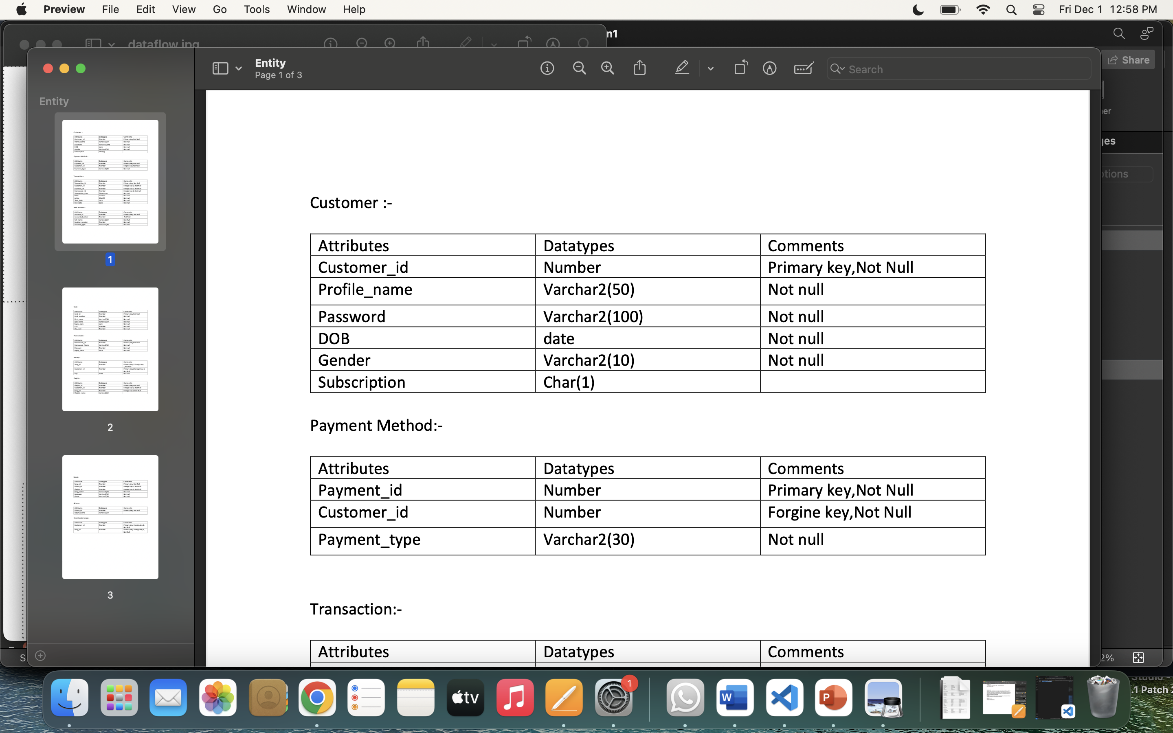

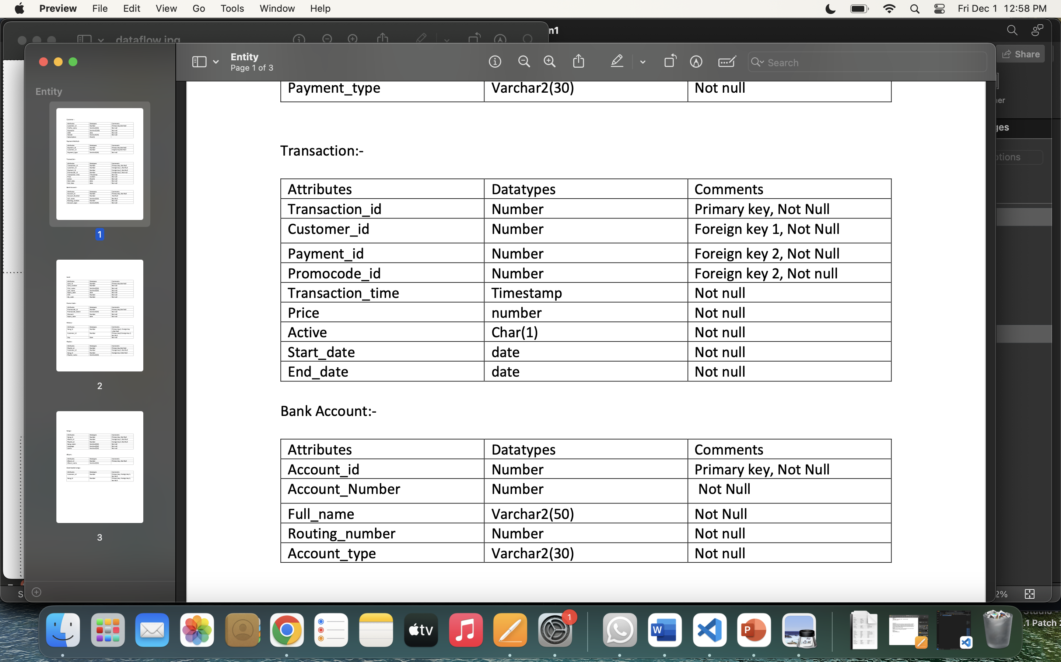

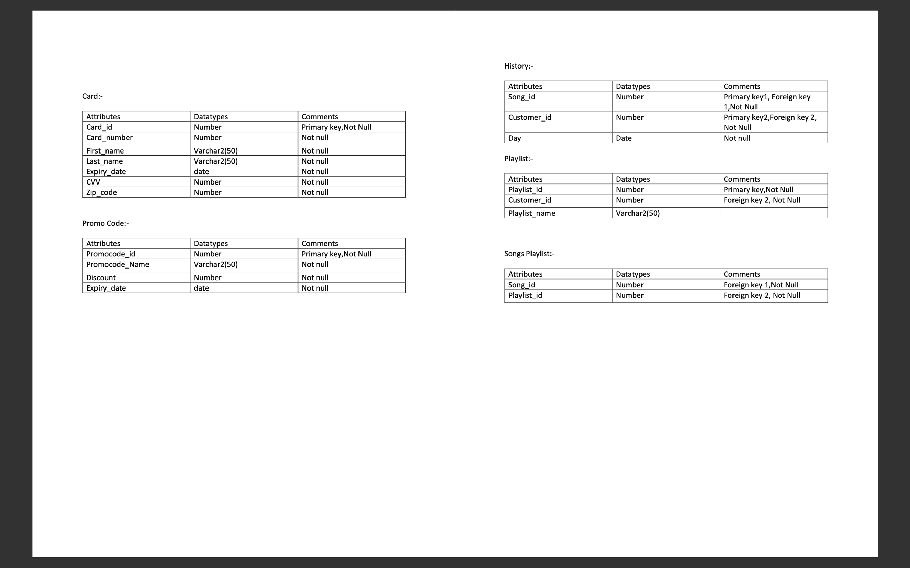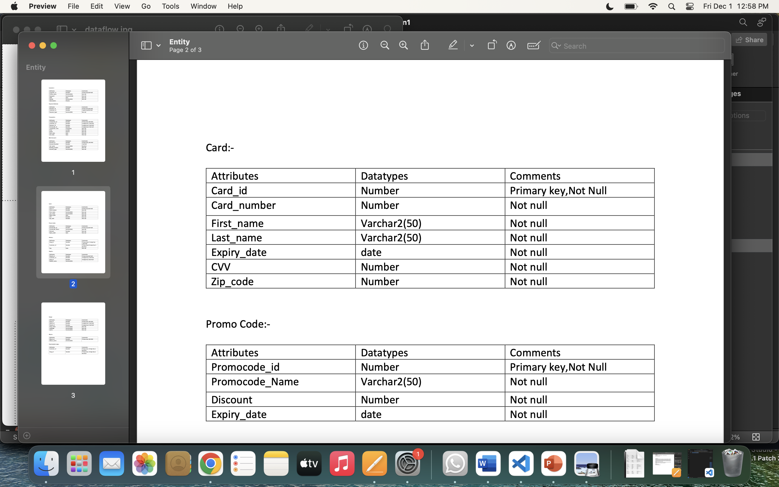

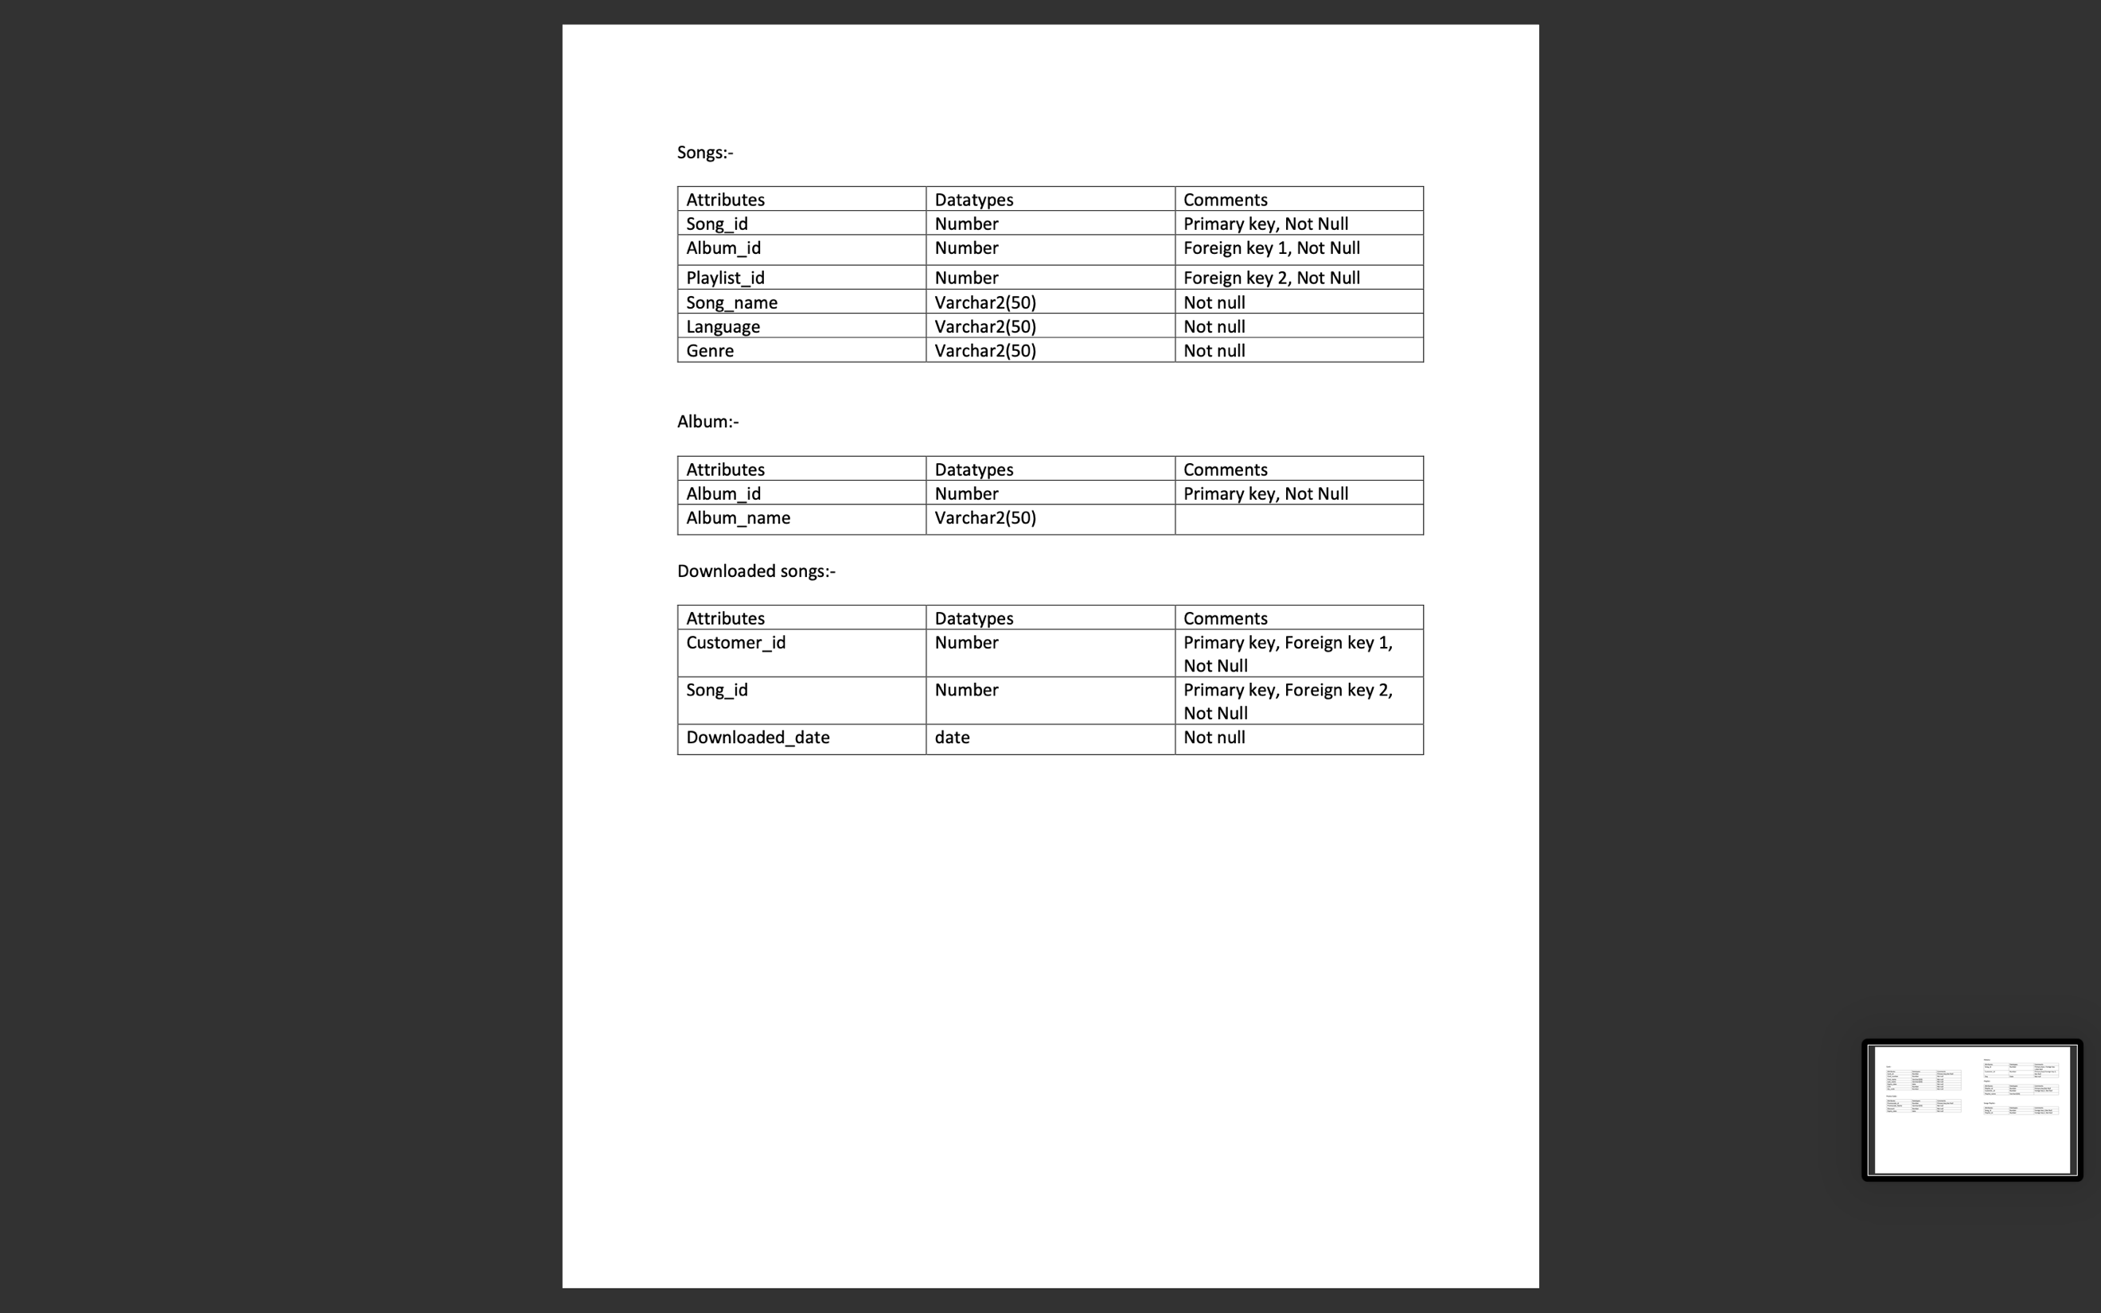

**Reports: -**

**SELECT * FROM Transaction_Payment_Type_Count;**

The "Transaction_Payment_Type_Count" view, established through a relational link between the "Transaction" and "Payment_Method" tables, offers a streamlined and aggregated perspective on transaction data. By employing the COUNT(*) function and GROUP BY clause, the view efficiently summarizes transaction counts according to distinct payment types. This abstraction enhances data accessibility, enabling stakeholders to quickly discern trends, make informed decisions, and refine business strategies related to payment processing. The view's scalability and dynamic nature further contribute to its utility, ensuring that analytical insights remain current with evolving transaction dynamics. In essence, the view serves as a pivotal tool for organizations seeking a concise and actionable understanding of transaction distribution across various payment methods.

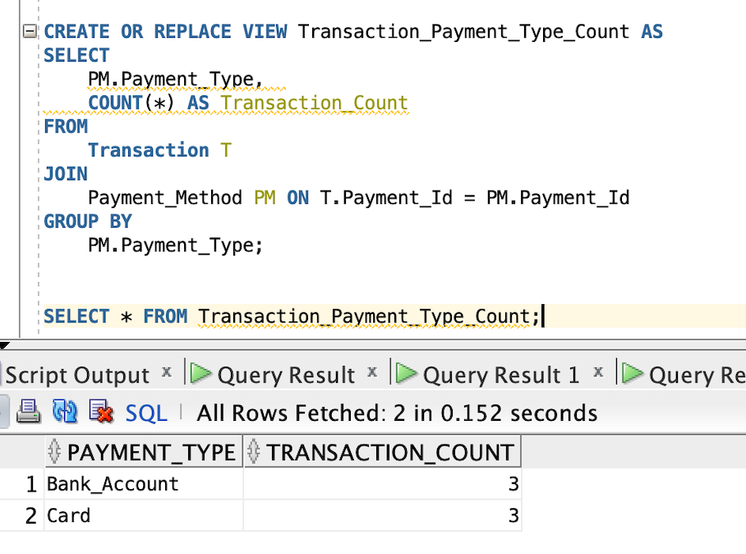

**SELECT * FROM Subscription_Status_Count;**

The "Subscription_Status_Count" view, derived from the "Customers" table, employs conditional COUNT statements to efficiently summarize customer counts based on subscription status. By distinguishing between "Y" (customers with an active subscription) and "N" (customers without a subscription), the view provides a clear and immediate representation of the distribution of subscribers and non-subscribers. This abstraction enhances data accessibility and serves as a decision support tool, enabling organizations to quickly assess the success of subscription-based services, refine retention strategies, and allocate resources effectively. The view's simplicity and adaptability to changes in the underlying dataset contribute to its utility as a dynamic and sustainable asset for ongoing analysis of customer

subscription dynamics.

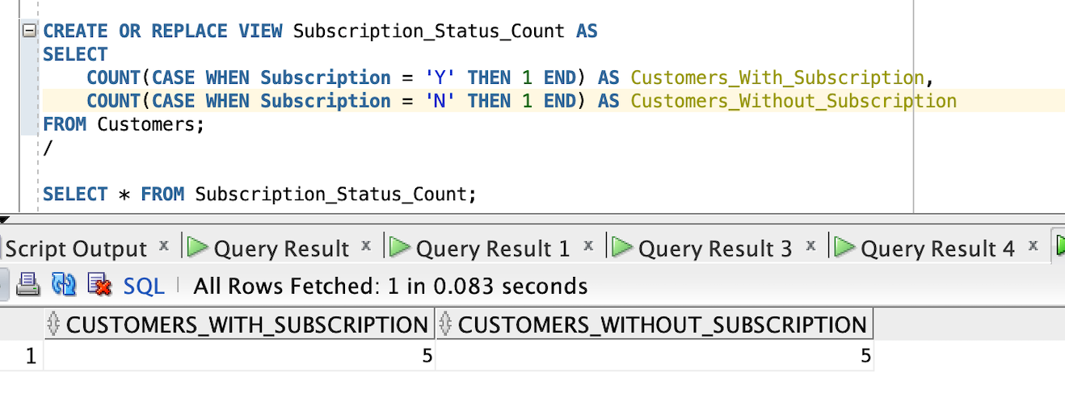

**SELECT * FROM Most_Downloaded_Songs;**

The "Most_Downloaded_Songs" view is created to offer insights into the most popular songs based on download counts within a music database. Utilizing joins between the "Songs," "Downloaded_Songs," and "Album" tables, the view aggregates data by song, including the song's ID, name, associated album name, and a count of downloads. The GROUP BY clause ensures that the results are grouped by unique combinations of song ID, song name, and album name, while the ORDER BY clause arranges the output in descending order of download counts, emphasizing the most downloaded songs first. This view serves as a valuable tool for music analytics, enabling users to quickly identify and assess the popularity of songs within the database, providing actionable insights for content curation and user engagement strategies.

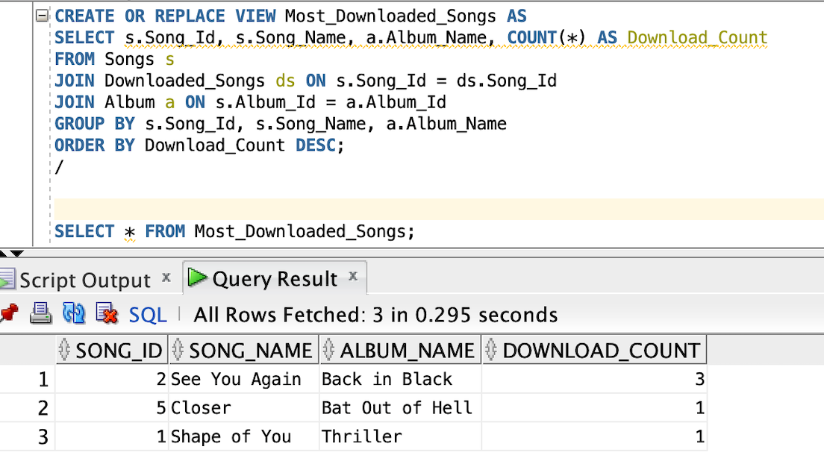

**SELECT * FROM Most_Listened_Song_And_Album;**

The "Most_Listened_Song_And_Album" view is designed to provide insights into the most frequently listened songs and their associated albums within a music database. Leveraging joins between the "Songs," "History," and "Album" tables, the view aggregates data by song, including the song's ID, name, associated album name, and a count of listens. The GROUP BY clause ensures that the results are grouped by unique combinations of song ID, song name, and album name, while the ORDER BY clause arranges the output in descending order of listen counts, spotlighting the most listened-to songs and their respective albums. This view serves as a valuable analytical tool for understanding user preferences and popular music trends, offering actionable insights for content curation and strategic decision-making in the context of user engagement and music recommendations.

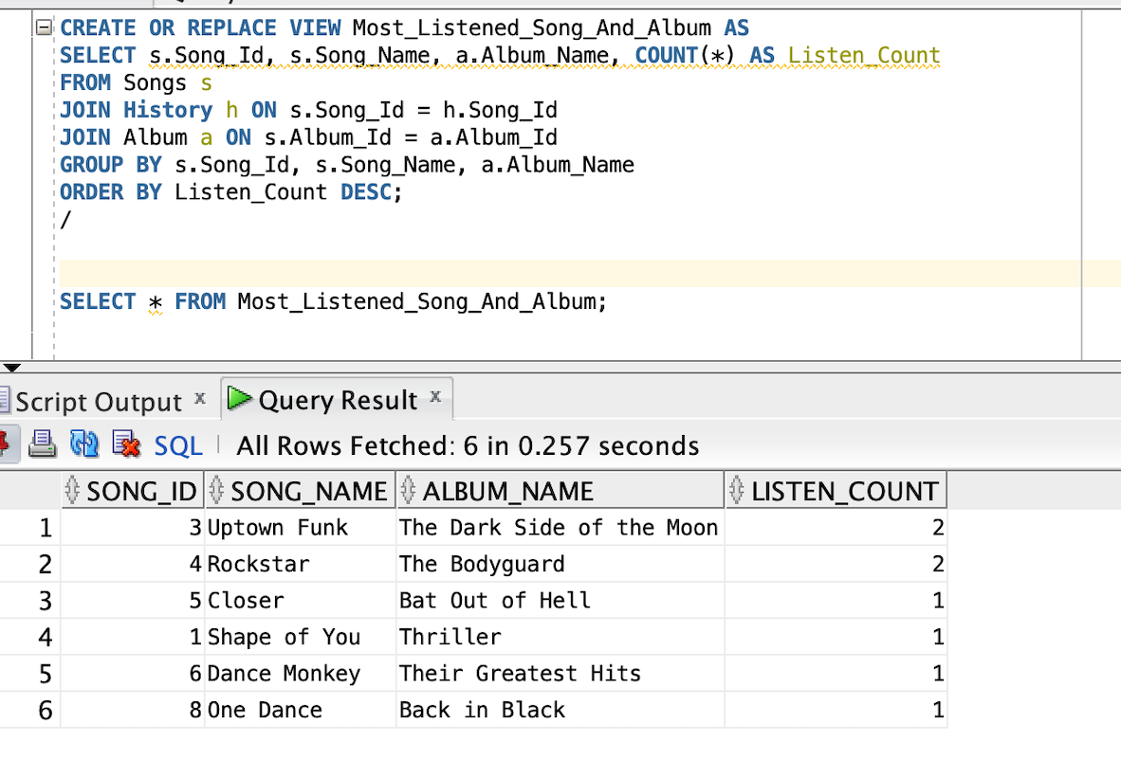

**SELECT * FROM Most_Used_Promocodes;**

The "Most_Used_Promocodes" view is constructed to provide a comprehensive analysis of the utilization of promotional codes within a transactional context. Through the JOIN operation between the "Promocodes" and "Transaction" tables, the view aggregates data based on unique promocode IDs and names, calculating the count of their usage. The GROUP BY clause ensures the results are organized by distinct promocodes, while the ORDER BY clause arranges the output in descending order of usage counts, highlighting the most frequently used promotional codes. This view serves as a valuable tool for marketing and sales analysis, offering insights into the effectiveness and popularity of different promotional campaigns. The data it provides can inform strategic decisions related to promotional efforts, allowing businesses to optimize their marketing strategies and allocate resources effectively to maximize the impact of promotional code campaigns.

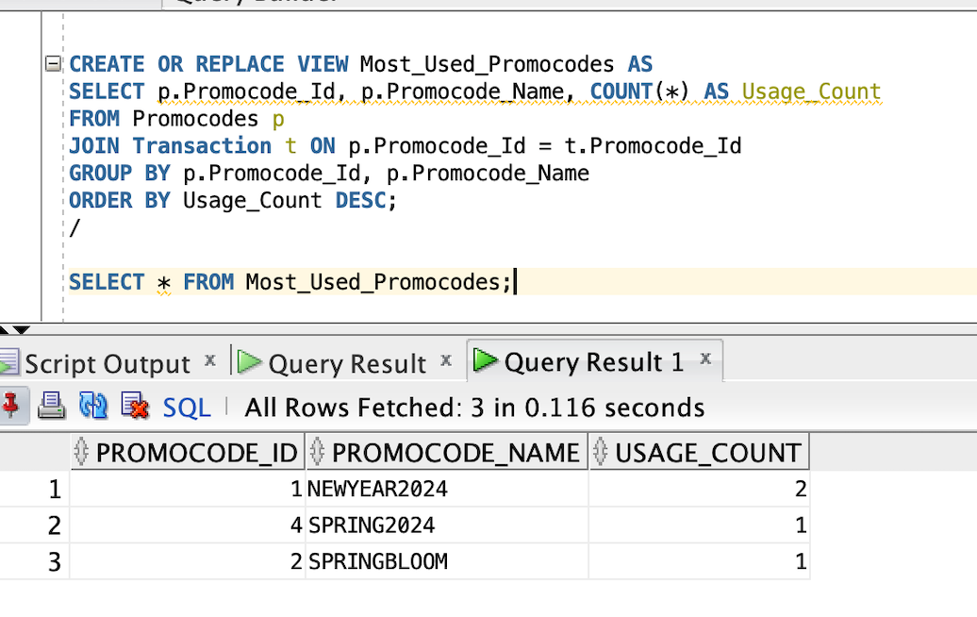

**SELECT * FROM Transaction_Outcomes;**

The "Transaction_Outcomes" view is designed to analyze the outcomes of transactions by categorizing them into two groups: "Succeeded_Transactions" and "Failed_Transactions." This classification is based on the combined price and discount values in the "Transaction" table, where a total of 20 is considered a successful transaction, while any other total is deemed a failed transaction. The use of a LEFT JOIN with the "Promocodes" table, linking transactions to their associated promotional codes, allows for the inclusion of any applicable discounts. The COUNT and CASE statements facilitate the aggregation of successful and failed transactions. This view serves as a valuable analytical tool for assessing the success rate of transactions, considering both regular prices and discounted amounts, providing insights into the effectiveness of promotions and potential issues with transactions that do not meet the expected total. Such insights can guide businesses in refining pricing strategies and optimizing promotional efforts to

enhance overall transaction success.

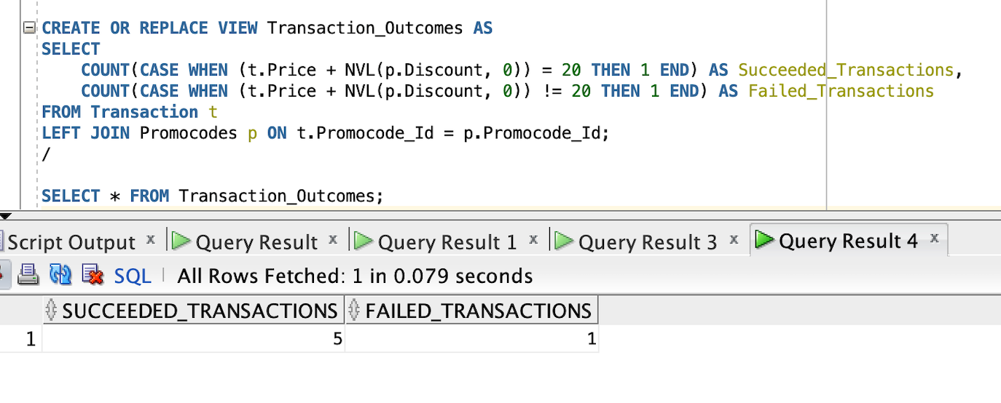

**SELECT * FROM Promocodes_Expiring_Soon;**

The "Promocodes_Expiring_Soon" view is crafted to provide timely information about promotional codes that are nearing their expiration date. Utilizing the "Promocodes" table, the view selects promocode details including ID, name, discount, and expiry date, but only includes those promocodes whose expiry date falls within the next 10 days from the current date. This view serves as a practical tool for marketing and promotional planning, offering insights into impending expirations and allowing businesses to proactively manage and strategize their promotional activities. By identifying promocodes that are about to expire, organizations can ensure timely promotions, communicate expiration details to customers, and potentially boost engagement and sales by leveraging the urgency associated with limited time offers.

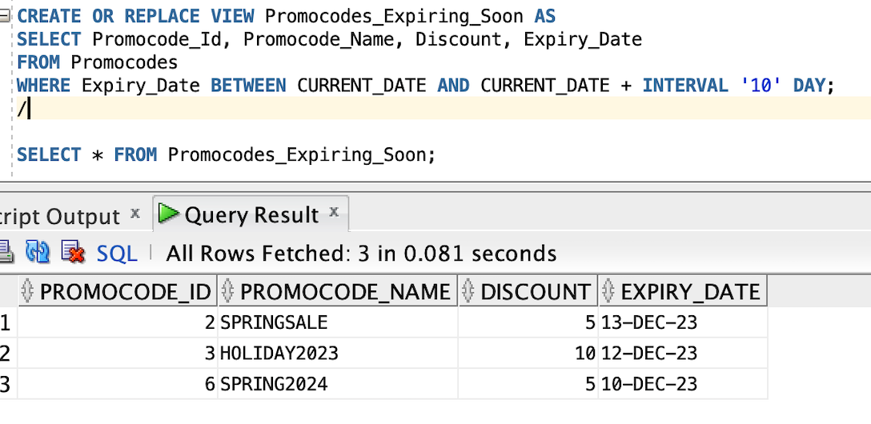

**SELECT * FROM Playlist_Summary;**

The "Playlist_Summary" view is designed to provide a concise overview of customer playlists by aggregating data from the "Playlist" and "Songs_Playlist" tables. The view selects and counts the number of songs in each playlist, associating the results with customer IDs and playlist names. Utilizing a JOIN operation on the "Playlist_Id" column, the view accurately links playlists to their corresponding songs. The GROUP BY clause ensures the results are organized by unique combinations of customer ID and playlist name. This view serves as a valuable analytical tool for understanding playlist composition and customer preferences, offering insights into the popularity and diversity of playlists. It facilitates efficient reporting on playlist metrics, aiding businesses in tailoring music recommendations, refining content curation strategies, and enhancing overall customer satisfaction in the realm of music streaming or distribution platforms.

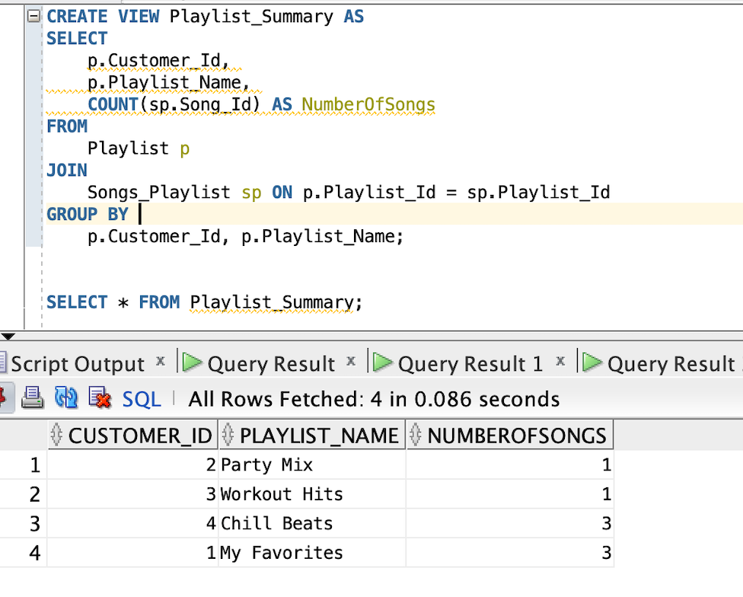

**SELECT * FROM User_Recommendations;**

The "User_Recommendations" view is crafted to provide tailored song recommendations for users based on their historical interactions with the music platform. The view selects distinct song details, including song ID, name, and genre, from the "Songs" table. The recommendation criteria involve songs whose genres have been either listened to or downloaded by users, as identified through the UNION of distinct genres from the "History" and "Downloaded_Songs" tables. To ensure that the recommendations align with user preferences, the view excludes songs that users have already interacted with, utilizing the NOT IN clause with subqueries that retrieve song IDs from the "History" and "Downloaded_Songs" tables. This view serves as a valuable tool for personalizing user experiences, providing a curated list of songs that are likely to match users' genre preferences while avoiding redundancy with their listening and download history.

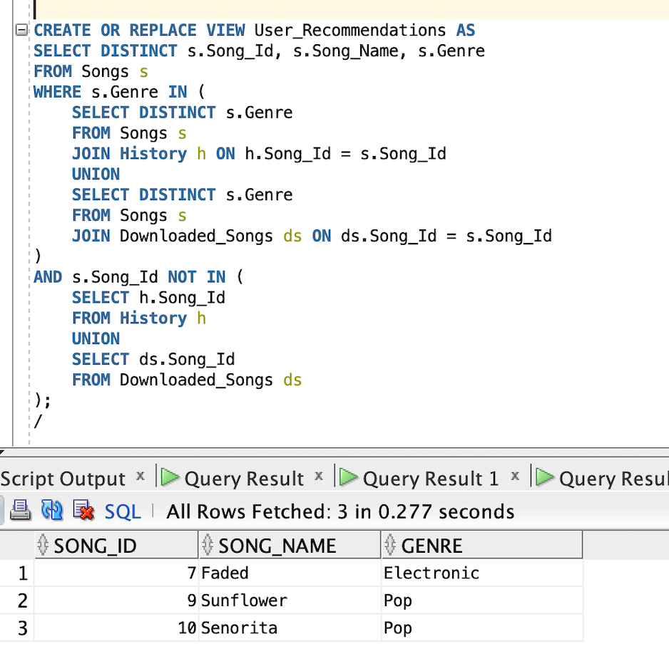

**SELECT * FROM User_Recommendation_By_Customer;**

The "User_Recommendation_By_Customer" view is specifically tailored to provide personalized song recommendations for a designated customer (identified by Customer_Id = 4 in this example) based on their individual listening history and downloaded songs within the music platform. Utilizing Common Table Expressions (CTEs) named "UserHistory" and "UserDownloads," the view captures distinct genres from the customer's history and downloads. The "AllGenres" CTE identifies all distinct genres available in the entire "Songs" dataset. The main query then selects distinct song details (song ID, name, and genre) from the "Songs" table for genres found in either the user's history or downloads, excluding songs the user has already interacted with. The OR NOT EXISTS clause ensures recommendations are provided even if the user has no prior history or downloads. This view serves as a sophisticated tool for delivering personalized music suggestions, considering the unique genre preferences of the specified customer, and avoiding repetition of songs already in their history or downloads. Users can thus enjoy a tailored and diverse listening experience based on their individual music consumption patterns.

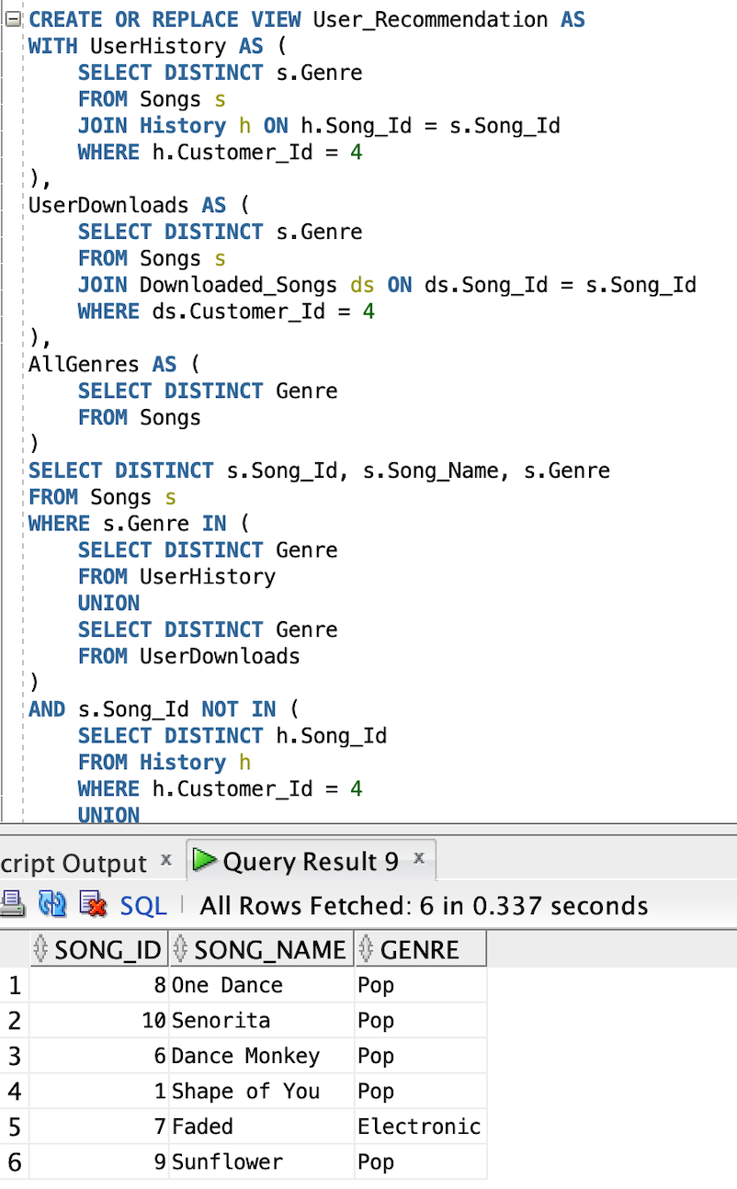

**Project Closure: -**

In this project as mentioned in our objective according to the user listened history we have recommended the playlist according to their taste and also we have made sure in the database contains their history of songs they have listened to so that they can go back and listen to the new songs they liked and get to know more about album.